Info for the ODD

To represent the structure of the transport system in the simulation model, a conceptual model was developed based on the CONSUMAT framework, which integrates various behavioral theories to elucidate the selection of products or services (Jager & Janssen, 2012). Additionally, elements from the MOSH framework (Faboya et al., 2020) and STECCAR (Kangur et al., 2017), which make adaptations of CONSUMAT in the context of modal choice, were incorporated to define the model for representing the decision-making of urban transport users.

Fig. 1 Conceptual model

The agents begin the simulation using a mode of transport among private car, motorcycle, or public transport, which is assigned according to their sociodemographic characteristics and the specific composition of the vehicle fleet in the city under study. In this case, three modes have been defined, which are those with the highest concentration of users in developing countries and, being motorized alternatives, contribute significantly to the issues of interest in this study: road accidents, CO2 emissions, and congestion.

Users aim to maximize their satisfaction with the trip made from their home to the corresponding destination during peak hours. Once the trip is completed, individuals analyze their surroundings and gather information from it to assess their satisfaction, while also accumulating usage experience with the mode used. With this information, each agent evaluates their own mental model and, depending on their particular situation, decides whether to continue using the same mode or to change it. Throughout the simulation, mode changes occur according to the strategies that agents adopt based on their mental models.

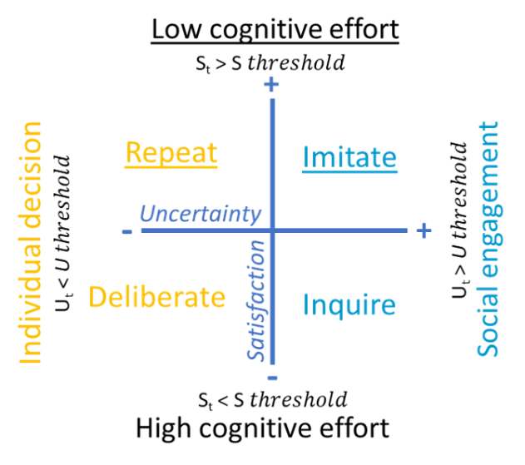

Fig.2. Possible strategies to make decisions based on the mental model

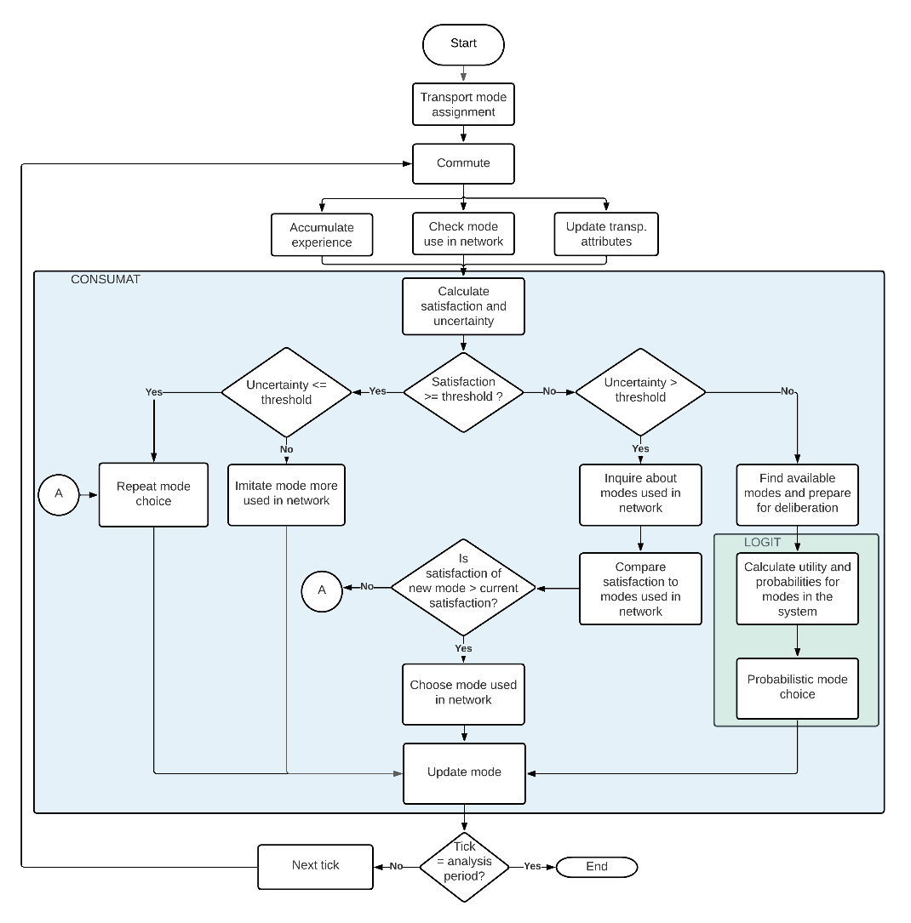

Fig. 3 Flowchart of the Metal model

These decisions are influenced by the internal mental state (current satisfaction with the mode of transport) and by behavioral control factors, including tolerance for uncertainty (uncertainty threshold) and desired satisfaction levels (satisfaction threshold).

Each agent has their own satisfaction thresholds (S threshold) and uncertainty thresholds (I threshold) that are compared with the values calculated after the trips are made (satisfaction in period t, *St*, and uncertainty in period t, *It*). Based on this comparison, individuals are divided into four types of decision-makers: repeaters, imitators, deliberators, and social comparers, also known as inquirers. Repeaters and imitators are satisfied with the mode used in the previous period, so they act automatically. For example, if a public transport user achieved a satisfaction level above their threshold and their level of uncertainty is below the maximum acceptable level, they will be classified as a repeater and will continue using public transport in the next period.

In contrast, the other two groups of individuals are dissatisfied and make decisions rationally, either by comparing with the alternatives used by their close social network (inquirers) or with the options available throughout the system (deliberators); for these two types of decisions, the choice involves greater cognitive effort, as the expected satisfaction must be quantified if one of the other available alternatives were chosen. Thus, someone with satisfaction below the expected level and uncertainty above their threshold will compare the satisfaction obtained with their current alternative against the satisfaction they would have obtained if they had chosen one of the modes used by their peers in the social network; this individual, using the inquiry strategy, will adopt the mode that provides the highest expected satisfaction in the next period.

Both repeaters and deliberators make their decisions individually, while imitators and inquirers rely on social interaction as a strategy to manage their uncertainty. Uncertainty can be understood as a mental state due to the inability to determine what the satisfaction with the chosen mode of transport will be, arising from a lack of information about transport modes. In this case, it can be mitigated by combining personal usage experience with the experiences of peers in the social network. Thus, the more accumulated experience using different modes of transport and the more information collected from other known individuals, the lower the level of uncertainty will be. In the model, uncertainty is calculated as a combination of accumulated personal and collective experience (from peers in the social network), weighted by a factor that determines the balance between the level of tolerance for uncertainty and the level of collectivism, which are influenced by the sociocultural context. This weighting factor is defined according to the measurements of cultural dimensions conducted by Hofstede (Hofstede et al., 2024).

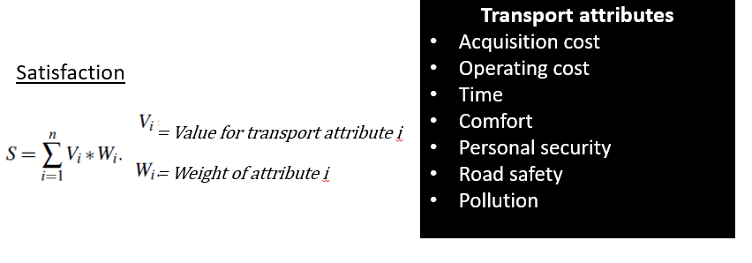

Trip satisfaction is calculated as a utility function, various attributes or needs that agents consider regarding transport modes were defined to calculate their satisfaction. These attributes include (1) acquisition cost, (2) operating cost, (3) road safety, (4) personal safety during the trip, (5) comfort in transport, (6) travel time, and (7) generated pollution. Each of these attributes has a variable degree of importance for individuals, allowing overall satisfaction to be determined through a weighted sum of the satisfactions associated with each specific need. The values obtained for these needs are affected by the state of the system resulting from the individual and aggregated decisions of the agents in each period. Aspects such as congestion, traffic accidents, and CO2 emissions vary depending on the number of cars, motorcycles, or buses in circulation, impacting the calculation of satisfaction for each of the factors that make up the overall satisfaction function. The weights are established considering the socioeconomic and cultural context; these were determined based on survey results, statistically comparing the differences between socioeconomic strata. In this way, the weight is assigned following a normal distribution with mean µ and standard deviation δ depending on their economic class.

**Purpose of the model:**

The purpose of the simulation model is to evaluate the potential effects of implementing policies aimed at mitigating externalities generated by utilitarian travel modes in urban contexts. To achieve this, agent-based simulation techniques have been employed, as it is necessary to represent the complex dynamics of urban transport systems, the spatial characteristics of the city, and at the same time, the heterogeneity of transport users. While the model can be used to explore different dynamics of urban transport mode choice, adapting it to different contexts, there is a specific interest in answering questions such as: How do individuals choose their mode of transport? How much does their social network influence this decision? What factors could promote the use of public transportation? Which factors have the most influence on its adoption? What measures could be most effective in reducing the impact of the externalities?

For the selected case study, the geographical area corresponds to the city of Cali. The available transport alternatives are motorcycles, private cars, and public transport (bus service in Cali). The agents are frequent transport users who need to travel from home to their workplace or study location. The model simulates this journey during a peak hour.

To make the model sufficiently realistic, parameters were defined to reproduce the pattern of transport user distribution according to their sociodemographic characteristics such as gender, age, and socioeconomic stratum. Similarly, variables were defined to represent the characteristics of trips and perceptions about transport modes. The geographical area to be analyzed and the transport modes considered also need to be characterized to reflect the real conditions of the system. Some of these attributes have been defined as initial variables or parameters, while others correspond to state variables, meaning they change over the simulated periods. Table 1 contains the parameters that determine the initial conditions of the simulation, and Table 2 describes the state variables.

Tabla 1 Parameters of the model

|  |  |  |  |  |
| --- | --- | --- | --- | --- |
| **Entity** | **Parameter** | **Description** | **Possible values** | **Units** |
| People | hPoly | person polygon ID | number > 0 | - |
| dist-home-work | Distance between patches assigned as home and work | number > 0 | kms |
| destination-community | Community where agent head to | 1-22 | - |
| % moto owners by socioeconomic-sit | Proportion of population with moto by socioeconomic situation | 0-1 | percentage |
| % car owners by socioeconomic-sit | Proportion of population with car | 0-1 | percentage |
| t-type | Initial transport mode assigned | motorcycle car public | - |
| alfa- uncertainty avoidance in Colombia | Level of uncertainty tolerated by Colombians | 0-1 | score |
| (1- alfa) - Colectivism in Colombia | Level of importance that people give to belonginess and cohesion in a group | 0-1 | score |
| age | Initial age of agents | 0- 70 | years |
| gender | Gender of agents | male (1) female (2) | - |
| h-social-type | Socioeconomic status of agents | 1: low  2: middle 3: high | - |
| home-location | Patch assigned as origin point | (x-y) | coordenates |
| workplace | Patch assigned as destination point | (x-y) | coordenates |
| uncertainty-threshold | Uncertainty tolerance level | 0-1 | score |
| Satisfaction-threshold | Level of satisfaction that a person wants to experience with the transport modes | 0-1 | score |
| W-buy | Level of importance that people give to acquisition cost | 0-1 | score |
| W-op | Level of importance that people give to operating cost | 0-1 | score |
| W-saf | Level of importance that people give to road safety | 0-1 | score |
| W-sec | Level of importance that people give to personal security | 0-1 | score |
| W-com | Level of importance that people give to comfort | 0-1 | score |
| W-time | Level of importance that people give to time of travel | 0-1 | score |
| W-pol | Level of importance that people give to emissions | 0-1 | score |
| Moto | moto-age | Moto age in tick 0 | 0-40 | years |
| cost-buy-mot | Motorcycle acquisition cost in tick 0 | 0-1 | score |
| costf-op-mot | Average fixed cost per km travelled | 0-1 | score |
| acc-rate-mot | Accident rate moto | 0-1 | accidents |
| speed-m | Initial motorcycle speed | number > 0 | km/h |
| insecur-m | Insecurity (crime) incident rate moto | 0-1 | incidents |
| eff-m | Fuel efficency moto | number > 0 | km/gallon |
| comfort-m | Comfort initial score motorcycles | 0-1 | Percentage |
| emi-mot | Moto CO2 emission rate | number > 0 | kg CO2 /km |
| Car | cost-buy-car | Car acquisition cost score | number > 0 | score |
| costf-op-car | Cost per km travelled score | number > 0 | score |
| acc-rate-car | Accident rate car | 0-1 | accidents |
| insecur-c | Insecurity (crime) incident rate car | 0-1 | incidents |
| speed-c | Initial car speed | number > 0 | km/h |
| eff-c | Fuel efficency car | number > 0 | km/gallon |
| comfort-c | Comfort initial score car | 0-1 | percentage |
| emi-car | Car CO2 emission rate | number > 0 | kg CO2 /km |
| Public | cost-buy-pub | Public cost of acquisition score | 0 | score |
| costf-op-pub | Public transport fare score | number > 0 | score |
| acc-rate-pub | Accident rate public | 0-1 | accidents |
| insecur-p | Insecurity (crime) incident rate public | 0-1 | incidents |
| speed-p | Initial public transport speed | number > 0 | Kg CO2 |
| comfort-p | Comfort initial score public | 0-1 | Percentage |
| acc-rate-pub | Public transport CO2 emission rate | number > 0 | Kg CO2 |
| reg-speed-pub | Regular-speed-public | number > 0 | km/h |
| default-wait-time | Default waiting time in the public system | number > 0 | minutes |
| capacity-public | Passengers capcity public system | number > 0 | person |
| Patches | CID | Community ID | 1-22 | category |
| centroid? | if it is the centroid of a polygon | True-false | category |
| community-social-type | Socioeconomic level of community | 1: low  2: middle 3: high | category |
| male-15-24  female-15-24 | People between 15 and 24 years old in the community | 0-1 | percentage |
| male-25-59 female-25-59 | People between 25 and 59 years old in the community | 0-1 | percentage |
| male-60 female-60 | People older than 60 years in the community | 0-1 | percentage |
| plow | Percentage of people living in the community in low class | 0-1 | percentage |
| med | Percentage of people living in the community in mid class | 0-1 | percentage |
| high | Percentage of people living in the community in high class | 0-1 | percentage |
| Occupied? | If there are more people in the patch | True-false | category |

Tabla 2 State variables

|  |  |  |  |  |
| --- | --- | --- | --- | --- |
| **Entity** | **Variable** | **Description** | **Possible values** | **Units** |
| People | age | Age of agent at the decision period | >15 | years |
| moto-owner | Indicates whether a person owns a motorcycle at the decision period | yes (1) no (0) | - |
| car-owner | Indicates whether a person owns a car at the decision period | yes (1) no (0) | - |
| transport-mode | Mode chosen in current period | motorcycle car public | - |
| satisfaction | Level of satisfaction obtained with the transport mode at the decision period | 0-1 | Percentage |
| uncertainty | Lack of certainty about the satisfaction that will obtain with the transport mode | 0-1 | Percentage |
| experience-moto | Number of periods using motorcycle | 0-simulation periods | Integer number |
| experience-car | Number of periods using car | 0-simulation periods | Integer number |
| experience-pub | Number of periods using bus | 0-simulation periods | Integer number |
| neighborsmymode | Number of neighbors using the same mode | number > 0 | Integer number |
| speed | Speed of travel at the time step t | number > 0 | kms/h |
| speed-mot | Speed of travel if agents goes by moto | number > 0 | kms/h |
| speed-car | Speed of travel if agents goes by car | number > 0 | kms/h |
| speed-pub | Speed of travel if agents goes by bus | number > 0 | kms/h |
| pollution | Sum of emissions per decision time | number > 0 | kg CO2 |
| dist-home-work | Distance between patches assigned as home and work | number > 0 | kms |
| dist-traveled | Accumulated distance of travel at the decision period t | number > 0 | kms |
| dist-trip | Distance of travel at the time step t | number > 0 | kms |
| kms | Equivalent number of kms for dist-traveled according to the zone | number > 0 | kms |
| time | Time of travel at the decision period | number > 0 | minutes |
| time-mot | Score of satisfaction obtained with travel time if agent goes by moto | 0-1 | score |
| time-car | Score of satisfaction obtained with travel time if agent goes by car | 0-1 | score |
| time-pub | Score of satisfaction obtained with travel time if agent goes by pub | 0-1 | score |
| density | Saturation level of roads around the agent | number > 0 | rate |
| comfort-mot | Score of comfort obtained with the moto at the decision period | 0-1 | score |
| comfort-car | Score of comfort obtained with the car at the decision period | 0-1 | score |
| comfort-pub | Score of comfort obtained with the bus at the decision period | 0-1 | score |
| safety | Indicates whether the person had a road accident | yes (1) no (0) | accidents |
| security | Indicates whether the person had a security incident | yes (1) no (0) | incidents |
| safety-mot | Score of safety obtained with the moto at the decision period | 0-1 | score |
| safety-car | Score of safety obtained with the car at the decision period | 0-1 | score |
| safety-pub | Score of safety obtained with the public at the decision period | 0-1 | score |
| security-mot | Score of security obtained with the moto at the decision period | 0-1 | score |
| security-car | Score of security obtained with the car at the decision period | 0-1 | score |
| security-pub | Score of security obtained with the public at the decision period | 0-1 | score |
| cost-op-mot | Score (relative operating cost transformed) for moto | 0-1 | score |
| cost-op-car | Score (relative operating cost transformed) for car | 0-1 | score |
| cost-op-pub | Score (relative operating cost transformed) for pub | 0-1 | score |
| Arrived? | true- made it to destination, false- commuting | True-false | category |
| type-choice | Result of the mental model evaluation | "repetition " "imitation " "inquiring" "deliberation" | - |
| Moto | moto-age | Motorcycle years old at decision period | 0-40 | years |
| costv-op-mot | Score for variable cost per km travelled | 0-1 | score |
| time-m | Accumulated travel time if agent goes by moto at the decision period | number > 0 | minutes |
| speed-mot | Speed of travel if agent goes by moto | number > 0 | kms/h |
| acc-mot-count | number of accidents by decision period | number > 0 | accidents |
| inc-mot-count | number of crime incidents by decision period | number > 0 | incidents |
| Car | costv-op-car | Score for variable cost per km travelled | 0-1 | score |
| time-c | Accumulated travel time if agent goes by car at the decision period | number > 0 | minutes |
| speed-car | Speed of travel if agent goes by car | number > 0 | kms/h |
| acc-car-count | number of accidents by decision period | number > 0 | accidents |
| inc-car-count | number of crime incidents by decision period | number > 0 | incidents |
| Public | time-p | Accumulated travel time if agent goes by bus at the decision period | number > 0 | minutes |
| speed-pub | Speed of travel if agent goes by bus | number > 0 | kms/h |
| acc-pub-count | number of accidents by decision period | number > 0 | accidents |
| inc-pub-count | number of crime incidents by decision period | number > 0 | incidents |
| wait-time-p | waite time for public transport | number >= 0 | minutes |

To assess whether the model adequately reflects the patterns of the real system concerning modal distribution, observations are made on the number of users of each mode of transport in each decision period. Similarly, the segmentation of individuals into the four types of decision-makers is monitored to observe the proportion in which people are applying different strategies to choose their mode of transport.

The model was implemented in the NetLogo 6.4 development environment, where the passage of time is measured in ticks, each representing 2 minutes. Each iteration corresponds to 30 ticks, which equals an average peak hour of a typical year. During each tick, agents accumulate information about their journey and the system. At the end of the iteration, the decision period is reached, at which point individuals calculate their satisfaction level on a scale from 0 to 1 for each of the seven factors considered in their choice: acquisition cost, operating cost, road safety, personal safety, comfort, travel time, and emissions. By applying the corresponding weighting level according to their socioeconomic class, agents calculate their overall satisfaction with the trip and their current uncertainty to compare them with their thresholds, which must have been previously established on a scale from 0 to 1, with zero being the minimum level and one the maximum. As a result, they apply one of the possible strategies (repeat, imitate, deliberate, or inquire) to choose the mode of transport they will use in the next period. At the system level, indicators are calculated to analyze the impacts of individual user choices. These include the tons of CO2 generated during peak hour, the annual accident rate, and the average travel time and speed.

The main processes that are calculated at every tick, are the commuting, calculation of congestion, update of travel variables such as safety, personal security and time. At every decision period there are some other additional processes: uncertainty the, other travel attributes update (comfort, pollution and costs) y satisfaction calculation. Based on these results, the final process is the decision making about the transport mode.

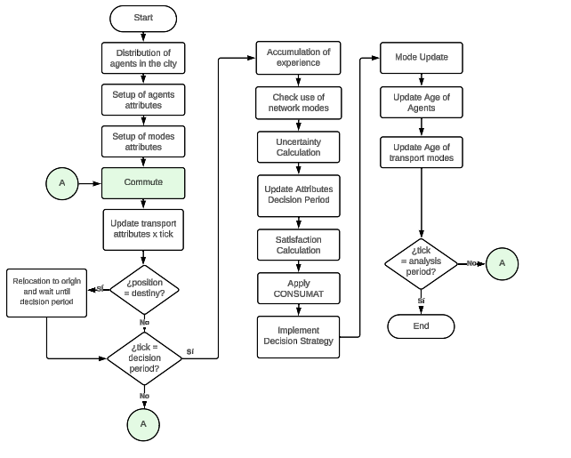

Fig. 4. Main processes in the model

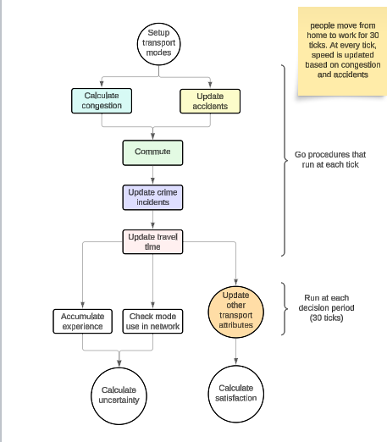

Fig.5 Processes running every tick

Fig.6 Processes running every tick detailed

Fig. 7 Commute flowchart

Design concepts:

* **Emergence:** As a result of the individual decisions of the agents, the modal distribution of the geographical area under study is obtained. The composition of the resulting vehicle fleet generates impacts on the amount of CO2 emissions produced, accident rates, and the average speed of the system.
* **Adaptation:** Agents seek to achieve a desired level of satisfaction when making their trips. When this threshold is not met, they follow a set of decision rules to apply one of three strategies (imitate, deliberate, or inquire) when choosing which mode of transport to use in the next period: motorcycle, car, or public transport.
* **Objectives:** The general objective of the agents is to maximize their overall satisfaction. This implies that the satisfaction obtained from each of the factors they consider in their mode choice should achieve the highest possible value in each evaluation period after completing the home-work trip (see Equation 2).
* **Learning:** Travelers accumulate usage experience with the selected transport modes throughout the simulation. This is used to calculate the level of uncertainty, which in turn influences the decision-making strategy applied by the agents. As a measure to mitigate the lack of information about a specific mode of transport, agents collect information from their network of contacts (learning from others), thus, the overall uncertainty is a combination of individual and collective experience.
* **Perception/Monitoring:** To calculate their individual satisfaction level, users consider their own variables (mode used, level of comfort experienced, emissions generated, travel time, fuel cost), system variables (number of traffic accidents, kg of CO2 emitted, number of vehicles in circulation), information from agents in the social network (modes used by contacts, incidents of crime experienced), and environmental conditions, such as the number of vehicles in nearby areas and the part of the city they are in.
* **Interaction:** Users interact with other people through their social network. The network is formed randomly following a scale-free structure. In it, some nodes or agents have a large number of connections, but the vast majority have a lower number of links. Following theories of human behavior that indicate people are more likely to relate to those with whom they share similarities, the probability of connecting with someone in the same socioeconomic stratum is greater than the probability of relating to someone from a different stratum.
* **Stochasticity:** In order to generate greater heterogeneity among agents and variability over time, some processes involve probabilistic parameters. For example, the effects of weather on comfort, the accident rate by mode, the rate of crime incidents, satisfaction and uncertainty thresholds, and the relevance levels for the attributes of transport modes.
* **Observation:** Some of the model's outputs are monitored at each tick, for example, viable accidents, security incidents, kilometers traveled, vehicle density on the road, average speed, and emissions generated. Other measurements are accumulated and updated at each decision period (every 30 ticks): average overall travel time and by mode, total kilometers traveled, average system speed and by mode, total CO2 emissions and by mode, average waiting time in public transport, total number of crime incidents, and global and mode-specific accident rates.